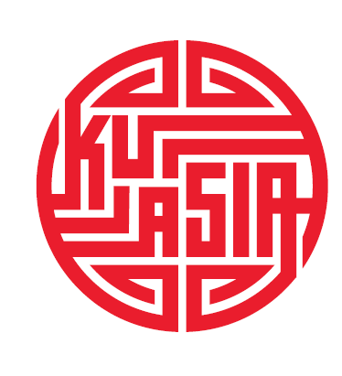

KOTRA (KOREA TRADE INVESTMENT PROMOTION AGENCY) PROGRAM
BY KUASIA AND KOÇ UNIVERSITY LAW SCHOOL

Topic: Essentials of Turkish labor law/Labor Relations in Turkey

March 2018

The seminar by Prof. Dr. Tankut Centel will provide essential information on the legal rights of employers and employees in Turkey, plus up-to-date sections on wages, employment contracts, working hours, discrimination laws, and unions for the Korean companies operating in Turkey. It will introduce participants to the major current debates in Turkish labor law. In addition, it offers an engaging overview of the development and status quo of labor law and industrial relations in Turkey.

Headlines of content:
> Historical background of Turkish labor law
> Legal sources of Turkish labor law
> Types of contract and employment
> Obligations of the parties throughout the employment contract
> Organization of work
> Work time
> Daily rest
> Annual rest and paid leave
> Wages
> Protection of women and young workers
> Termination of the employment contract
> Notice for the termination of the employment contract
> Termination of the employment contract with just cause
> Severance pay
> Union freedom
> Consequences of breach of union freedom
> Organization of unions
> Membership and union activities
> Concluding of collective labor agreement
> Amicable ways of settlement in collective labor disputes
> Mediation, arbitration and reconciliation
> Strikes and lockouts

